Name : Dev Adnani  
SID : 202212012

Subject : Systems Programming

Assignment : 10

Q1 : 202212012_Lab10_1.c

#include <stdio.h>

#include <stdlib.h>

#include <unistd.h>

#include <string.h>

#include <math.h>

#include <pthread.h>

pthread_mutex_t myMutex;

int ptable[5][3];

int entry = 0;

int reRandomCheck(int processId);

void *pTableWriteMutex(void *str);

void *pTableReadMutex(void *str);

int main()

{

int ret;

pthread_t threads[20];

ret = pthread_mutex_init(&myMutex, NULL);

for (int i = 0; i < 20; i++)

{

if (i % 2 == 0)

pthread_create(&threads[i], NULL, pTableWriteMutex, NULL);

else

pthread_create(&threads[i], NULL, pTableReadMutex, NULL);

}

for (int i = 0; i < 20; i++)

{

pthread_join(threads[i], NULL);

}

for (int i = 0; i < 5; i++)

{

printf("%d %d %d\n", ptable[i][0], ptable[i][1], ptable[i][2]);

}

ret = pthread_mutex_destroy(&myMutex);

exit(0);

}

int reRandomCheck(int processId)

{

for (int i = 0; i < entry; i++)

{

if (ptable[entry][0] == processId)

{

processId = rand() % 10;

return processId;

}

}

return processId;

}

void *pTableWriteMutex(void *str)

{

int processID = rand() % 10;

int pageNumber = (rand() % 1000) + 50;

int frequency = 1;

pthread_mutex_lock(&myMutex);

if (entry < 5)

{

processID = reRandomCheck(processID);

ptable[entry][0] = processID;

ptable[entry][1] = pageNumber;

ptable[entry][2] = frequency;

entry++;

}

else

{

int minFrequencyValue = ptable[0][2];

int minFrequencyPos = 0;

for (int i = 1; i < 5; i++)

{

if (ptable[i][2] < minFrequencyValue)

{

minFrequencyValue = ptable[i][2];

minFrequencyPos = i;

}

}

processID = reRandomCheck(processID);

ptable[minFrequencyPos][0] = processID;

ptable[minFrequencyPos][1] = pageNumber;

ptable[minFrequencyPos][2] = frequency;

}

pthread_mutex_unlock(&myMutex);

}

void *pTableReadMutex(void *str)

{

int processID = rand() % 10;

pthread_mutex_lock(&myMutex);

for (int i = 0; i < 5; i++)

{

if (ptable[i][0] == processID)

{

ptable[i][2]++;

}

}

pthread_mutex_unlock(&myMutex);

}

Screenshot :

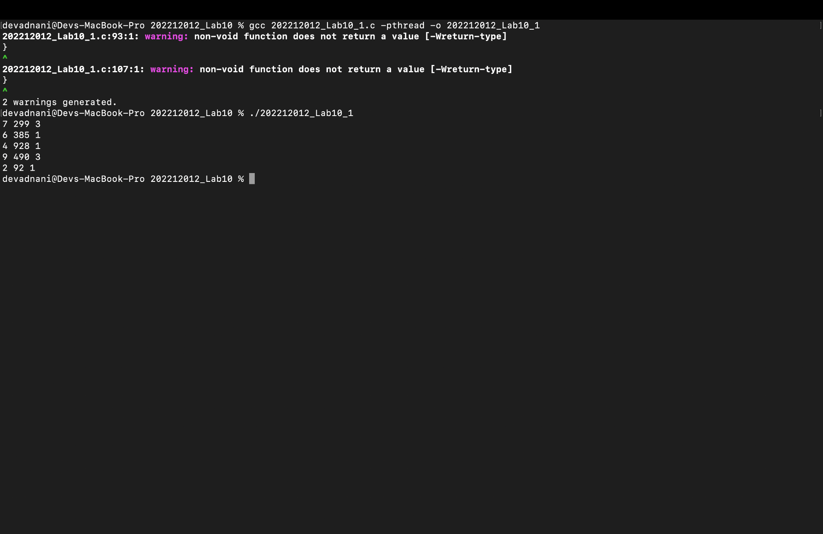

Q2 : 202212012_Lab10_2.c

#include <stdio.h>

#include <stdlib.h>

#include <unistd.h>

#include <string.h>

#include <math.h>

#include <pthread.h>

pthread_rwlock_t rwLock;

int ptable[5][3];

int entry = 0;

int reRandomCheck(int processId);

void *pTableWriteRW(void *str);

void *pTableReadRW(void *str);

int main()

{

int ret;

pthread_t threads[20];

ret = pthread_rwlock_init(&rwLock, NULL);

for (int i = 0; i < 20; i++)

{

if (i % 2 == 0)

pthread_create(&threads[i], NULL, pTableWriteRW, NULL);

else

pthread_create(&threads[i], NULL, pTableReadRW, NULL);

}

for (int i = 0; i < 20; i++)

{

pthread_join(threads[i], NULL);

}

for (int i = 0; i < 5; i++)

{

printf("%d %d %d\n", ptable[i][0], ptable[i][1], ptable[i][2]);

}

ret = pthread_rwlock_destroy(&rwLock);

exit(0);

}

int reRandomCheck(int processId)

{

for (int i = 0; i < entry; i++)

{

if (ptable[entry][0] == processId)

{

processId = rand() % 10;

return processId;

}

}

return processId;

}

void *pTableWriteRW(void *str)

{

int processID = rand() % 10;

int pageNumber = (rand() % 1000) + 50;

int frequency = 1;

pthread_rwlock_wrlock(&rwLock);

if (entry < 5)

{

processID = reRandomCheck(processID);

ptable[entry][0] = processID;

ptable[entry][1] = pageNumber;

ptable[entry][2] = frequency;

entry++;

}

else

{

int minFreqVal = ptable[0][2];

int minFreqPos = 0;

for (int i = 1; i < 5; i++)

{

if (ptable[i][2] < minFreqVal)

{

minFreqVal = ptable[i][2];

minFreqPos = i;

}

}

processID = reRandomCheck(processID);

ptable[minFreqPos][0] = processID;

ptable[minFreqPos][1] = pageNumber;

ptable[minFreqPos][2] = frequency;

}

pthread_rwlock_unlock(&rwLock);

}

void *pTableReadRW(void *str)

{

int processID = rand() % 10;

pthread_rwlock_rdlock(&rwLock);

for (int i = 0; i < 5; i++)

{

if (ptable[i][0] == processID)

{

ptable[i][2]++;

}

}

pthread_rwlock_unlock(&rwLock);

}

Screenshot :

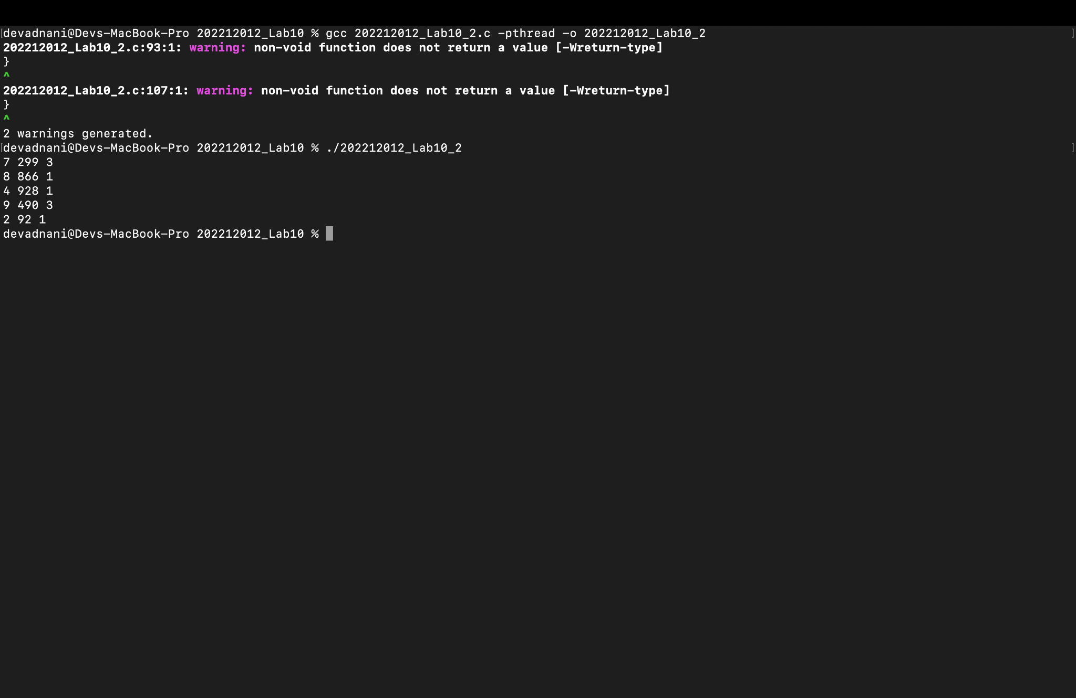

Q3: 202212012_Lab10_3.c

#include <stdio.h>

#include <stdlib.h>

#include <unistd.h>

#include <string.h>

#include <math.h>

#include <pthread.h>

#include <semaphore.h>

sem_t semaphore;

int p_table[5][3];

int entry = 0;

int reRandomCheck(int processId);

void *pTableWriteRW(void *str);

void *pTableReadRW(void *str);

int main()

{

sem_init(&semaphore, 0, 20);

pthread_t threads[20];

for (int i = 0; i < 20; i++)

{

if (i % 2 == 0)

pthread_create(&threads[i], NULL, pTableWriteRW, NULL);

else

pthread_create(&threads[i], NULL, pTableReadRW, NULL);

}

for (int i = 0; i < 20; i++)

{

pthread_join(threads[i], NULL);

}

for (int i = 0; i < 5; i++)

{

printf("%d %d %d\n", p_table[i][0], p_table[i][1], p_table[i][2]);

}

exit(0);

}

int reRandomCheck(int processId)

{

for (int i = 0; i < entry; i++)

{

if (p_table[entry][0] == processId)

{

processId = rand() % 10;

return processId;

}

}

return processId;

}

void *pTableWriteRW(void *str)

{

int processID = rand() % 10;

int pageNumber = (rand() % 1000) + 50;

int frequency = 1;

sem_wait(&semaphore);

if (entry < 5)

{

processID = reRandomCheck(processID);

p_table[entry][0] = processID;

p_table[entry][1] = pageNumber;

p_table[entry][2] = frequency;

entry++;

}

else

{

int minFrequencyValue = p_table[0][2];

int minFrequencyPos = 0;

for (int i = 1; i < 5; i++)

{

if (p_table[i][2] < minFrequencyValue)

{

minFrequencyValue = p_table[i][2];

minFrequencyPos = i;

}

}

processID = reRandomCheck(processID);

p_table[minFrequencyPos][0] = processID;

p_table[minFrequencyPos][1] = pageNumber;

p_table[minFrequencyPos][2] = frequency;

}

sem_post(&semaphore);

}

void *pTableReadRW(void *str)

{

int processID = rand() % 10;

sem_wait(&semaphore);

for (int i = 0; i < 5; i++)

{

if (p_table[i][0] == processID)

{

p_table[i][2]++;

}

}

sem_post(&semaphore);

}

Screenshot :

